**Kate Moreland**

**kem0149**

**904239271**

**COMP 5120**

**Homework 4**

1. Suppose that a page can contain at most four data values and that all data values are integers. Using only B+ trees of order 2, give examples of each of the following:
   1. A B+ tree whose height changes from 2 to 3 when the value 25 is inserted. Show your structure before and after the insertion.

Before:



After:

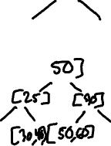

* 1. A B+ tree in which the deletion of the value 30 leads to a redistribution. Show your structure before and after the deletion.

Before:



After:



* 1. A B+ tree in which the deletion of the value 35 causes a merging of two nodes but without altering the height of the tree.

Before:

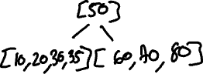

After:

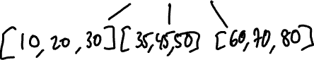

1. Answer the following questions about Linear Hashing:
   1. How does Linear Hashing provide an average-case search cost of only slightly more than one disk I/O, given that overflow buckets are part of its data structure?

Linear Hashing will distribute the data equally between hash buckets so it doesn’t result in an overflow. When more data is added, the original data will remain in the main bucket.

* 1. Does Linear Hashing guarantee at most one disk access to retrieve a record with a given key value?

No, Linear Hashing does not guarantee that. Whenever a record is in the overflow bucket, it may require additional I/O.